**DAILY ONLINE ACTIVITIES SUMMARY**

|  |  |  |  |  |  |  |  |  |
| --- | --- | --- | --- | --- | --- | --- | --- | --- |
| **Date:** | **01/06/2020** | | | | | **Name:** | **Kavana V** | |
| **Sem & Sec** | **6th A** | | | | | **USN:** | **4AL17CS040** | |
| **Online Test Summary** | | | | | | | | |
| **Subject** | | **CNSC IA Test - 2** | | | | | | |
| **Max. Marks** | | **60** | | **Score** | | | **52** | |
| **Certification Course Summary** | | | | | | | | |
| **Course** | **Web Development with python and JavaScript** | | | | | | | |
| **Certificate Provider** | | | **Harvard University** | | **Duration** | | | **12weeks** |
| **Coding Challenges** | | | | | | | | |
| **Problem Statement:**   1. Python program to delete duplicate elements from the list. 2. Python program which accepts a sequence of comma-separated numbers from user and generate a list and a tuple with those numbers. | | | | | | | | |
| **Status: Completed** | | | | | | | | |
| **Uploaded the report in GitHub** | | | | | **Yes** | | | |
| **If yes Repository name** | | | | | <https://github.com/vgkavana/Online-coding-> | | | |
| **Uploaded the report in slack** | | | | | **Yes** | | | |

**Online Test Details**

CNSC TEST-2 Details:

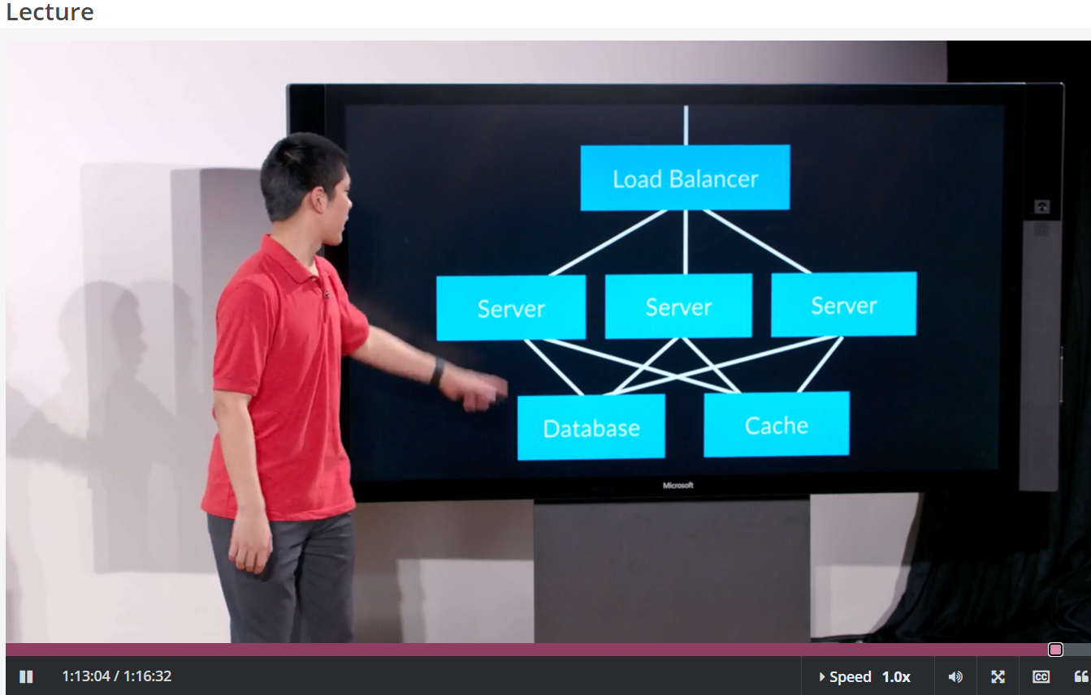 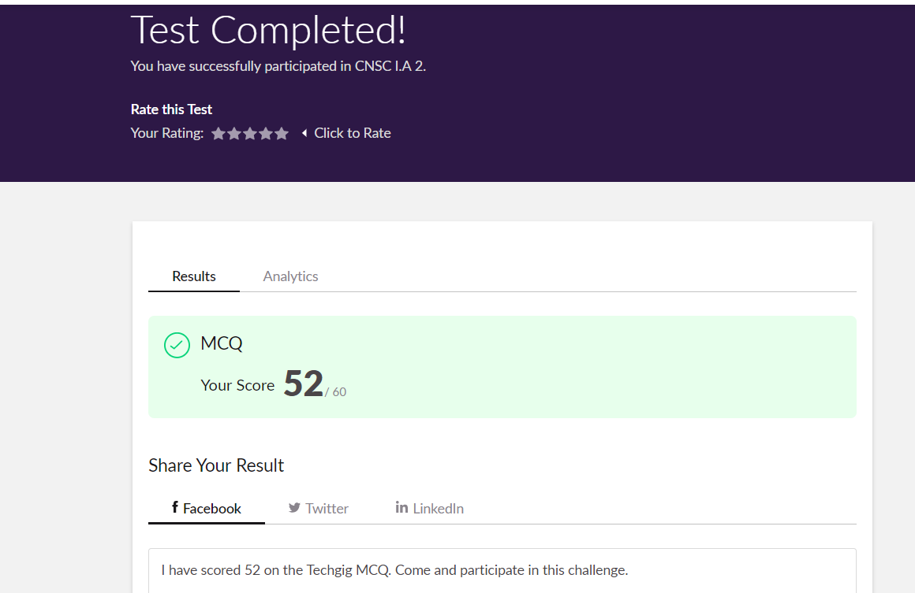

**Online Certification Details**

**Lesson**

* Scalability

**Coding Challenge Details**

1. Python program to delete duplicate elements from the list.

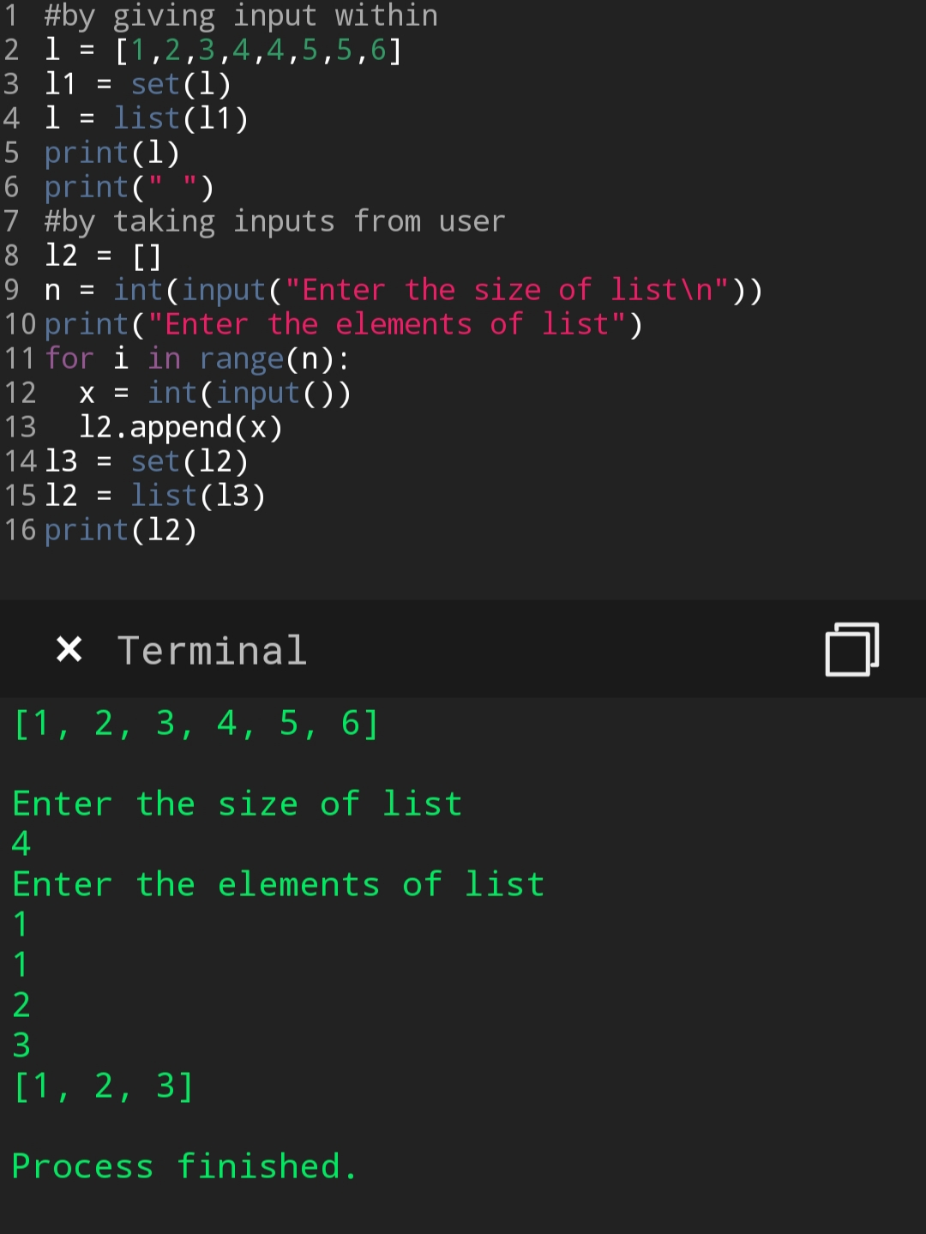

1. Write a Python program which accepts a sequence of comma-separated numbers from user and generate a list and a tuple with those numbers.

